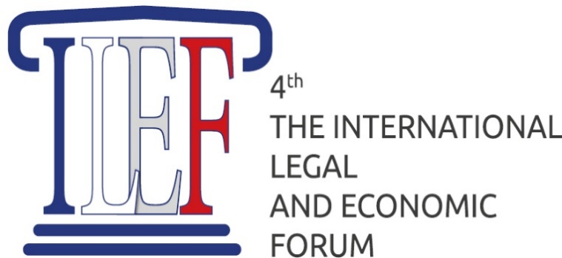

International Festival “Legal Science and International Cooperation”
September 12, 2021

within IV International Forum “Modern Problems of Law and Economics in Europe and Asia”
September 12-15, 2021

Organizer:
International Alliance of Jurists and Economists (France)


Co-Organizer:
Kutafin Moscow State Law University (MSAL)
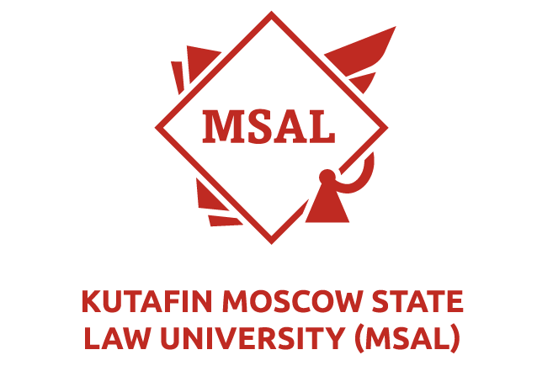
Supported by:
International Cooperation Department of the Kutafin Moscow State Law University (MSAL)
Extra-Curricular Activity Department of the Kutafin Moscow State Law University (MSAL)
Private International Law Department, Legal Modelling Department, Department of Integration and European Law, Department of Practical Jurisprudence of the Kutafin Moscow State Law University (MSAL)

Partners:

Federal Service for Intellectual Property (Rospatent).
Russian State Academy of Intellectual Property (RSAIP)
Swiss Centre for International Humanitarian Law (Zurich, Switzerland)
University of Johann Heinrich Pestalozzi (Miami, USA)

September 12, 2021 (Sunday)
11:00-15:00

Welcoming addresses by

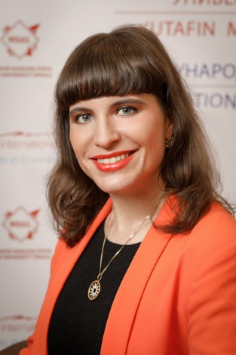
Maria EGOROVA, Doctor of Law, Professor, Co-President of the International Alliance of Lawyers and Economists (France), Head of the International Cooperation Department of the Kutafin Moscow State Law University (MSAL), Professor Emeritus of Johann Heinrich Pestalozzi University (Miami, USA), Professor Emeritus of Logos University (Miami, USA).

Time  (Moscow time) | Lector | Workshop | Zoom link
11.00-12.00 | 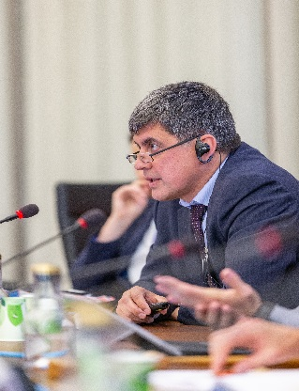  Alexander V. GORBUNOV, Advisor to the Director of the Federal Institute of Industrial Property (Russia) | The Dawn of Technology or the "Data Revolution" |   https://msal-ru.zoom.us/j/95340987110
12.00-13.00 | 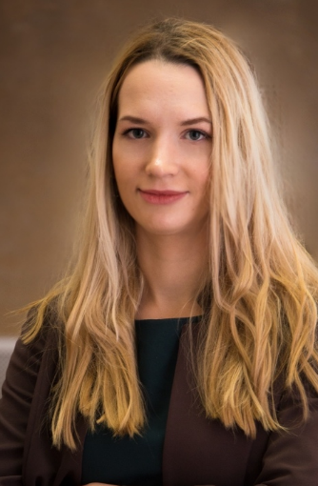  Olesia F. ZASEMKOVA, Associate Professor of the Private International Law Department, Associate Professor of the Legal Modeling Department of the Kutafin Moscow State Law University (MSAL), PhD in Law (Russia) | Problems of Legal Regulation of Artificial Intelligence
13.00-14.00 | 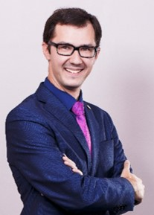  Vitaly Y. SLEPAK, Associate Professor of the Integration and European Law Department of the Kutafin Moscow State Law University (MSAL), PhD in Law (Russia) | Organizational Legal Forms for Megascience Projects: International and National Experience
14.00-15.00 | 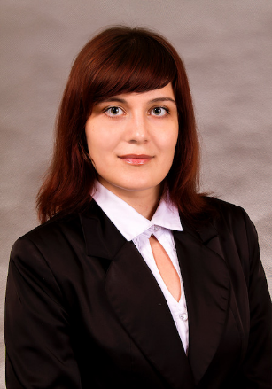  Daria V. PONOMAREVA, Deputy Head of the Department Practical Jurisprudence Department of the Kutafin Moscow State Law University (MSAL), PhD in Law (Russia) | Legal Research.  The Toolkit of a Successful Lawyer
15.00-16.00 | Presentation of competition works by the participants of the festival  Moderators of the contest:  Maria EGOROVA, Forum President , Doctor of Law, Professor, Co-President of the International Alliance of Lawyers and Economists (France), Head of the International Cooperation Department of the Kutafin Moscow State Law University (MSAL), Member of the Executive Committee of the Moscow branch of Association of Lawyers of Russia, Member of the International Committee for the Digital Economy, Professor Emeritus of Johann Heinrich Pestalozzi University (Miami, USA), Professor Emeritus of Logos University (Miami, USA).  Olesia F. ZASEMKOVA, Associate Professor of the Private International Law Department, Associate Professor of the Legal Modeling Department of the Kutafin Moscow State Law University (MSAL), PhD in Law

Nominations:

- The best presentation and scientific article "Legal Science of the Future"
- The best essay "The Role of Law in Human Life"
- Social advertising "Man and Law"
- Artworks "Symbol of the Law"

September 15, 2021 (Wednesday)

15.00-16.30
Closing of the I International fest «Legal Science and International Cooperation»



